Presentation Outline: EV Battery Health & Capacity Estimation – From Research to Real-World Application
P.S. All the references to the paper are about this one:
“He, Haowei, J. Zhang, Yanan Wang, Benben Jiang, Shaobo Huang, Chen Wang, Yang Zhang, Xue Lei Han, Dongxu Guo, Guannan He and Minggao Ouyang. “EVBattery: A Large-Scale Electric Vehicle Dataset for Battery Health and Capacity Estimation.” (2022).”

Step 1: The Business & Real-World Challenge
- Narrative (Commercial & Tech): The rapid adoption of Electric Vehicles (EVs) brings crucial challenges in battery safety and lifespan estimation. Traditionally, estimating battery health requires chemical and physical tests; however, these methods are destructive, rendering the battery unusable and causing significant economic losses. To solve this, we looked at the latest state-of-the-art academic research, which proposes a non-invasive, data-driven approach. By analyzing everyday charging data, it is possible to accurately estimate the remaining cruise range of a vehicle without taking it apart.
Step 2: The Foundation – Leveraging Academic Research
- Narrative (Tech to Commercial): Rather than reinventing the wheel, our system is built upon a proven methodology detailed in a recent, highly regarded scientific paper. The researchers originally validated this pipeline on a massive real-world dataset comprising over 1.2 million charging snippets from 464 different EVs. The core logic we adopted is simple but powerful: we extract continuous charging data and segment it into sliding windows of exactly 128 time-points. For each point, we track 8 key physical variables—such as average cell voltage, current, temperatures, and State of Charge (SOC)—following the exact formatting prescribed by the study.
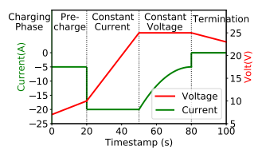
Figure 1. Related to the paper

Step 2.5: How the AI "Thinks" (The Logical Flow)
- Narrative (Tech to Commercial): To understand how the model we implemented estimates capacity, we can compare it to a doctor performing a stress ECG. The doctor doesn't look at a single isolated heartbeat; they observe how the heart responds and fatigues over time. The Artificial Intelligence architecture we adopted does exactly the same thing during the charging process.
  - Ingesting the "Symptoms" (Raw Data): During charging, the neural network receives the vital signs in real-time: Voltage (how hard we are pushing), Current (how much energy is entering), and Temperature (how hot it's getting).
  - Observation over Time (The 128x8 Matrix): The model doesn't process data randomly; it "stretches" it into a perfect temporal sequence of 128 frames. This allows the algorithm (an LSTM network) to have "memory" and compare the beginning of the charge with the end.
  - The Secret Reasoning (Feature Extraction): This is where the mathematical magic happens. The model learns to notice patterns invisible to the human eye, such as subtle voltage rises relative to the injected current, which indicate an increase in internal resistance.
  - The Verdict (Compression): All these temporal clues are compressed and filtered. The final result converges into a single, highly precise number: the residual Capacity in Ah.
- Suggested Image:
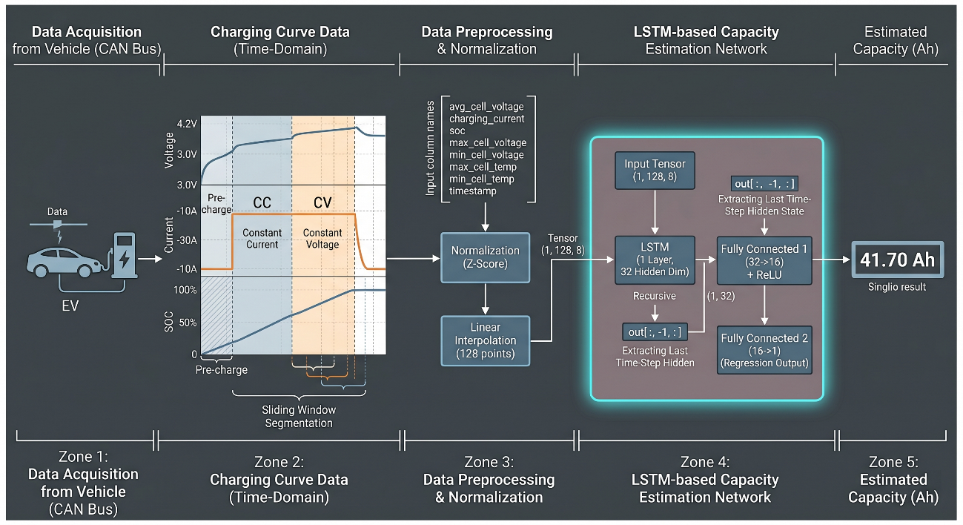
Step 3: The Core Technology – Focusing on Capacity Estimation
- Narrative (Tech Focus): The original academic paper explored two distinct branches using these 128x8 matrices: Health Anomaly Detection (using a DyAD algorithm) and Capacity Estimation. For our current platform, we made the strategic decision to focus exclusively on Capacity Estimation, leaving the anomaly detection branch out of our current scope. To estimate how much charge the battery can still hold (measured in Ah), we successfully implemented the LSTM (Long Short-Term Memory) neural network proposed by the researchers. This specific regression model has proven highly effective at reading charging curves and translating them into battery degradation metrics.
Step 4: Proven Reliability – Our Replication Milestone
- Narrative (Commercial & Tech): The most important milestone of our current work is that we have successfully replicated the paper's Capacity Estimation results on our own cloud infrastructure. By carefully reconstructing the data formatting, handling the normalizers, and avoiding issues like "domain shifts" (which occur when raw data scales differ from training data distributions), we have proven that this academic pipeline is reliable and fully functional in an industrial environment. We have effectively bridged the gap between a theoretical paper and a working, deployable API.
- Suggested Image: A side-by-side bar chart or scatter plot demonstrating our API's predicted capacity aligning closely with the actual battery capacity, proving the success of our technical replication.
Step 5: The Future – Scaling Up to the Mainstream Market
- Narrative (Commercial Vision): Having successfully validated the research pipeline, our next strategic step is to scale up beyond the academic dataset. We are actively planning to acquire new, proprietary datasets focusing on a wider and more common pool of commercial vehicles. The research proves that using raw, unanonymized data yields the same high predictive power. By applying the pipeline we've built to broader vehicle fleets, we can leverage transfer learning to adapt these models to different manufacturers. This will unlock massive commercial value for fleet management, predictive maintenance, and the secondary battery market.

